Risk | Likelihood of risk (0,5) | Impact of risk (0,5) | Severity of risk | Mitigating Action
Loss of impact data | 1 | 5 | 5 | Impact data has been emailed to me, so they are stored in the cloud – decreasing the likelihood
Loss of code | 1 | 5 | 5 | Code backed up to GitHub (Cloud Service)
Loss of dissertation document | 1 | 5 | 5 | Backed up
No correlations in the data collected | 3 | 2 | 6 | Explain in discussion about possible reasons why the expected correlations didn’t exist
Poor image quality of samples leading to large errors | 2 | 3 | 6 | Make sure images are taken on camera with suitable lighting to give best chance of detail coming through on the image  Make sure all images are taken in the highest quality possible

Risk Register

Gantt Chart

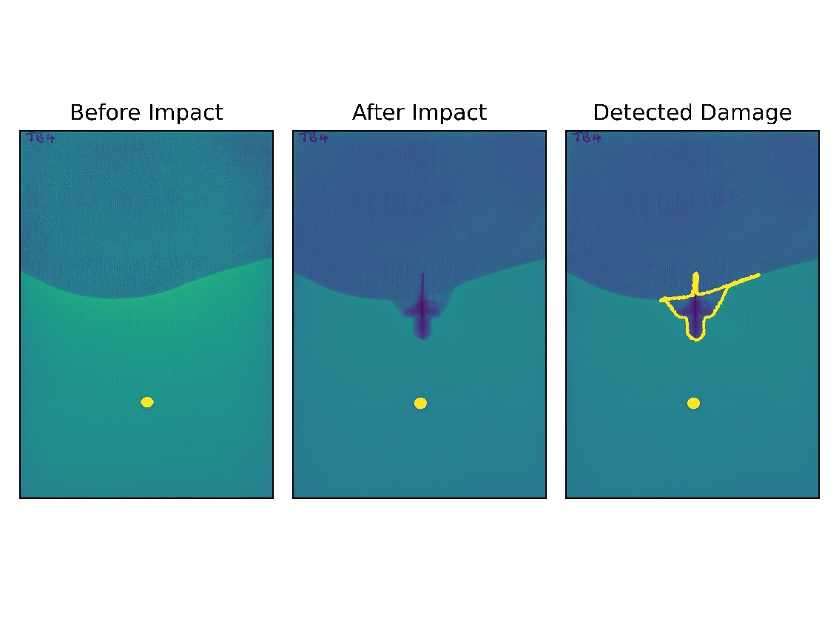
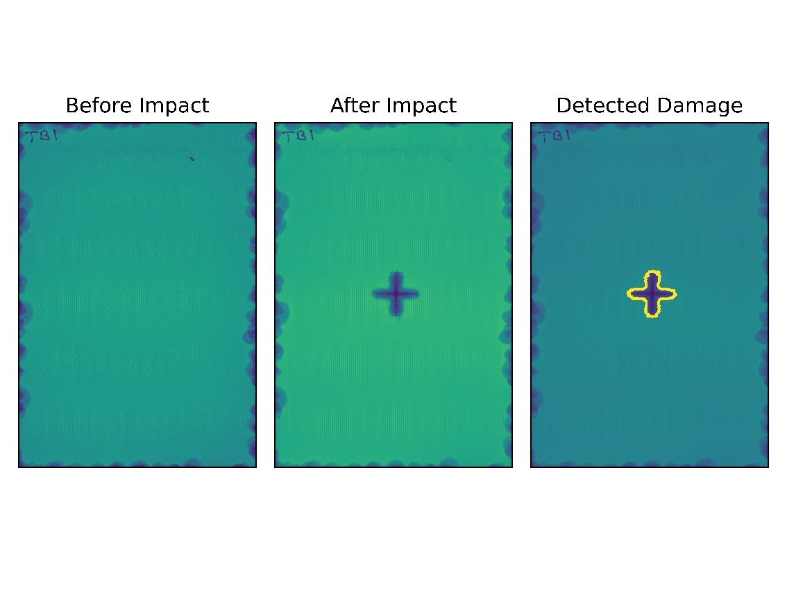
Damage Detection

Damage Data
